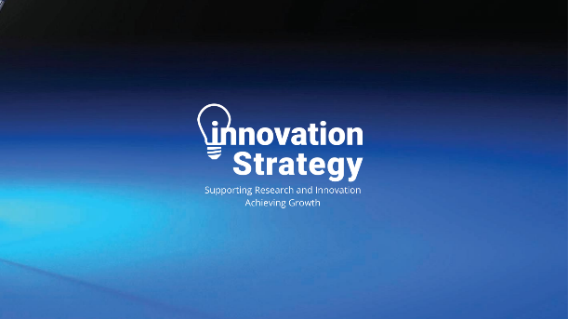

**MID WALES LAUNCH PAD SKILLS BUILDER**

**Mid Wales Launch Pad Skills Builder**

**Deadline 16th August 2024**

**Summary**

A 12-week placement that will help you gain new skills and knowledge, stimulate new ideas, build confidence, and create exciting new career opportunities for yourself alongside innovative businesses.

Complete the simple from below and return to launchpad@aberinnovation.com

All applicants will receive an email response by the end of September 2024. We will introduce you to the businesses and you will complete the necessary documentation to begin your placement.

|  |
| --- |
| **Personal Details** |
| Name  Address  Telephone number  Email address |
| **Why do you want to take part in the programme (100 words)** |
|  |
| **What industry are you interested in?** |
|  |
| **What skills do you hope to achieve?** |
|  |
| **What experience or current skills do you have? If limited, please describe your interests.** |
|  |